SI Overarching SIT Functional Readiness Report
Document owner | Document number | Version
Dominic Mooney | MHHS-DEL2266 | V1.0
Status: | Date | Classification
Approved | 11 March 2024 | Public

Document owner | Document number | Version
SI Workstream Lead | MHHS-ART029 | 0.4
Status: | Date | Classification
Draft | 26 May 2022 | Public

Document owner | Document number | Date

Contents
1 SI Overarching SIT Functional Readiness Report 2
1.1 Change Record 2
1.2 Document Review & Approval 2
1.3 Document References 2
1.4 Terminology 3
1.5 Document Purpose and Guidance 3
2 SIT Functional Readiness Status 5
2.1 SIT Functional Readiness Status Guidance 5
2.2 SIT Functional Readiness Status – Central Party 6
2.3 SIT Functional Readiness Status – Cohort A 7
2.4 SIT Functional Readiness Status – Cohort B 8
2.5 SIT Functional Readiness Status – Cohort C 9
2.6 SIT Functional Readiness Status – Cohort E 10
2.7 SIT Functional Readiness Status – Cohort F 11
2.8 SIT Functional Readiness Status – Cohort G 12
2.9 SIT Functional Readiness Status – Cohort H 13
2.10 SIT Functional Readiness Status – Cohort J 14
3 Placing Reliance 15
4 Secondary Routing 15
5 SI SIT Functional Entry Criteria Status 16
5.1 SI Owned SIT Functional Readiness Work Off Items 17
6 SIT Functional Preparation – Milestones, Statuses & Work-off Plans 18
6.1 SIT Functional Preparation – Milestones, Statuses & Work-off Plans (Part I) 18
6.2 SIT Functional Preparation – Milestones, Statuses & Work-off Plans (Part II) 19
7 Risks & Issues 20
8 SI SIT Functional Readiness Recommendation 20
Appendix A – SIT Functional Readiness Tracker 21

Lists of Figures

Figure 1: SIT Functional Readiness Status – Central Party 6
Figure 2: SIT Functional Readiness Status - Cohort A 7
Figure 3: SIT Functional Readiness Status – Cohort B 8
Figure 4: SIT Functional Readiness Status – Cohort C 9
Figure 5: SIT Functional Readiness Status – Cohort E 10
Figure 6: SIT Functional Readiness Status – Cohort F 11
Figure 7: SIT Functional Readiness Status – Cohort G 12
Figure 8: SIT Functional Readiness Status – Cohort H 13
Figure 9: SIT Functional Readiness Status – Cohort J 14

Lists of Tables

Table 1: Secondary Routing Activities 15
Table 2: Secondary Routing Work Off Items 15
Table 3: SI SIT Functional Entry Criteria Status 16
Table 4: SI owned SIT Functional Readiness Work Off Items 17
Table 5: SIT Functional Milestones Pt I (as of 08-Mar-24 at 4pm) 18
Table 6: SIT Functional Milestones Pt II (as of 08-Mar-24 at 4pm) 19

SI Overarching SIT Functional Readiness Report

Change Record
Date | Author | Version | Change Detail
13 February 2024 | Dominic Mooney | 0.1 | Initial report content compiled for review
19 February 2024 | Nigel Hunt | 0.2 | Updated information from Readiness Review Reports & SIT Readiness Tracker
22 February 2024 | Nigel Hunt / Dominic Mooney / Lee Cox | 0.3 | Updated information from Readiness Review Reports & SIT Readiness Tracker in revised Cohort reporting format
29 February 2024 | Nigel Hunt / Dominic Mooney / Lee Cox | 0.4 | Report updated with latest readiness position as of 29th February, in addition to an updated SIT Functional Readiness Tracker embedded in Appendix A.
7 March 2024 | Dominic Mooney / Lee Cox | 0.5 | Report updated with latest readiness position as of 7th March, in addition to an updated SIT Functional Readiness Tracker embedded in Appendix A.
8 March 2024 | Dominic Mooney / Lee Cox | 0.6 | Report updated with latest readiness position as of 8th March, in addition to an updated SIT Functional Readiness Tracker embedded in Appendix A.
11 March 2024 | Fraser Mathieson | v1.0 | Approved as v1.0 by SIT Advisory Group (SITAG)

Document Review & Approval
Name | Role | Organisation | Review / Information / Approval / Sign Off
Lee Cox | MHHS SI Programme Test Manager | MHHS LDP SI | Approval
Adrian Ackroyd | MHHS SRO Client Test Programme Manager | MHHS SRO | Approval
Kiran Raj | MHHS SRO SIT Functional Test Lead | MHHS SRO | Review
SIT Advisory Group | MHHS governance oversight group for SIT | MHHS Governance | Approval

Document References
Ref No. | Document/Link | Publisher | Published | Additional Information
REF-01 | MHHS-DEL1259 SIT Functional Test Approach & Plan | SI Testing | 16 August 2023
REF-02 | MHHS-DEL2254 SIT Functional Readiness Tracker | SI Testing | Updated weekly on the MHHS Collaboration Bases | Updated weekly on the MHHS Collaboration Bases
REF-03 | MHHS-DEL1064 - Placing Reliance Policy | SI Testing | 27 April 2023
REF-04 | MHHS-DEL852 - Pre-Integration Test Guidance | SI Testing | 18 August 2023
REF-05 | MHHS-DEL618 - Environment Approach & Plan | SI Testing | 21 July 2023
REF-06 | MHHS-DEL1367 - SIT Functional Test Data Approach & Plan | SI Testing | 16 August 2023
REF-07 | MHHS RAID Log – please contact PMO@mhhsprogramme.co.uk for Raid Log access. | PMO | -

Terminology
Term | Description
Various | For terminology, see Programme Glossary on the MHHS portal:  Programme Glossary (SharePoint.com)

Document Purpose and Guidance
The Market-wide Half Hourly Settlement programme (MHHS), when completed, will contribute to a more cost-effective electricity system, encouraging more flexible use of energy and helping consumers lower their bills.

The objective of the Functional Test stage is to validate the new MHHS arrangements by involving all Central Systems, the Registration Service and at least two Services for each market Role, all connected via the Data Integration Platform (DIP) enabling End-to-end functional tests to be conducted. These End-to-end tests are based on business scenarios and are aimed to exercise and “prove” the MHHS E2E Design. For full details of the background of this SIT Functional Test stage, please refer to [REF-01] MHHS-DEL1259 SIT Functional Test Approach & Plan.

Prior to System Integration Test (SIT) Functional Test commencement, each participant is required to provide a Participant SIT Functional Test Readiness Report as a formal self-declaration of their SIT Functional readiness status in relation to their preparation activities as outlined in section 7.1.5 of [REF-01] MHHS-DEL1259 SIT Functional Test Approach & Plan.
The objective of the Participant SIT Functional Test Readiness Report is to demonstrate the preparedness of testing efforts for each organisation entering SIT functional. As a key milestone before the commencement of testing activities, the report aims to ensure that all necessary components and prerequisites are in place to conduct testing efficiently and effectively.
The report will need to include:
- A completion status of Test participant owned SIT Functional readiness activities which have been specified in [REF-02] MHHS-DEL2254 SIT Functional Readiness Tracker.
- A statement and supporting evidence against the Test participant owned SIT functional Entry Criteria, as documented in section 7.1.6 in [REF-01] MHHS-DEL1259 SIT Functional Test Approach & Plan.
- Details of any exceptions i.e., readiness tasks, entry criteria, open PIT defects that have not been completed, met or resolved at the time of writing of the readiness report, and the associated work off plans and dates agreed with the MHHS programme for when these activities are planned to be completed.
- For Qualifying participants that have adopted the [REF-03] MHHS-DEL1064 - Placing Reliance Policy, evidence will need to be provided that demonstrates their proposal has been accepted by the Programme and that a placing reliance RACI has been agreed with their 3rd Party providers and the MHHS SI.
- Any new risks or issues to declare.
- Evidence that the Test participant Readiness Report has been approved and signed by a senior stakeholder authority within the Qualifying participants’ organisation, i.e., an approval from a delegated 3rd party provider only will not suffice.
Individual organisations’ Participant SIT Functional Test Readiness Report provide the formal input into an SI Overarching SIT Functional Readiness Report for SIT (this report), which aggregates the readiness position of all participants in addition to the SI owned readiness activities and entry criteria (as specified in section 7.1.6 of [REF-01] MHHS-DEL1259 SIT Functional Test Approach & Plan), and to document any risks, issues or exceptions and associated work off plans that impact the planned SIT Functional test execution start date. The status and recommendations in this report will feed into a MHHS programme governance decision via SITAG on whether to proceed with SIT Functional Test execution.
Please note that this is an interim report which confirms the position on SIT functional readiness tasks and entry criteria, documenting exceptions and work off plans at the time of writing. The progress status through to closure of any work off plans will be reported to the relevant governance forums making a decision to approve commencement of testing.

SIT Functional Readiness Status

SIT Functional Readiness Status Guidance
The following slides within Section 2 provide SIT Functional Readiness Task Status. Each slide will contain:
- Overall Status Table
- Readiness Declaration Table
- Overall Readiness Date Planned
- Work Off Plan

The Overall Status Table is split into 6 rows, each which will contain the readiness status against a set of sub-activities as listed below:
- PIT – SIT Functional
  - PIT Approach and Plan
  - PIT Requirements to Test Traceability Matrix
  - PIT Test Scenarios
  - Final PIT Completion Report
  - PIT Execution
  - PIT Completion Status
- CIT
  - CIT PP Completion Report Received
  - CIT PP Completion Report Assured
- Environments
  - CSS Connectivity Proving Complete (If Applicable)
  - DTN Connectivity Proving Complete
  - Intra-Cohort Connectivity established
  - MHHS code deployed to SIT PPs' envs
- Data
  - PPs confirmation that data is ready for SIT Functional
- ADO
  - PP verifies that tests have been allocated correctly

The details for all lower level activities can be viewed in [REF-02] MHHS-DEL2254 SIT Functional Readiness Tracker, which is updated weekly on the MHHS Collaboration Base. See also REF-02, copy embedded in Appendix A.

SIT Functional Readiness Status – Central Party
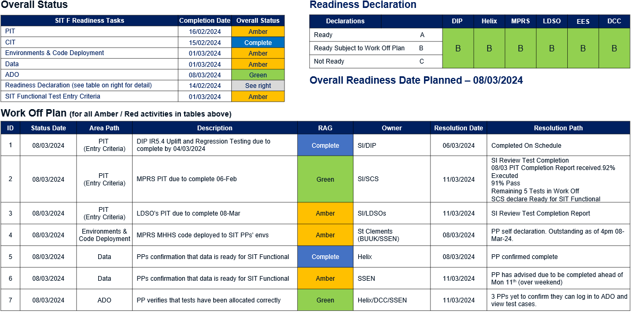
Figure 1: SIT Functional Readiness Status – Central Party

SIT Functional Readiness Status – Cohort A
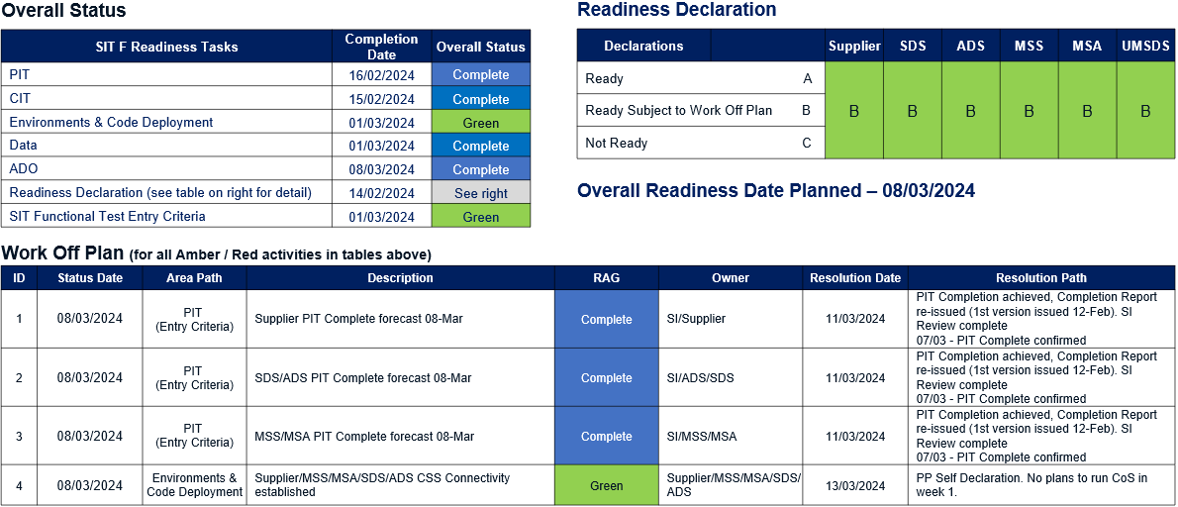
Figure 2: SIT Functional Readiness Status - Cohort A

SIT Functional Readiness Status – Cohort B
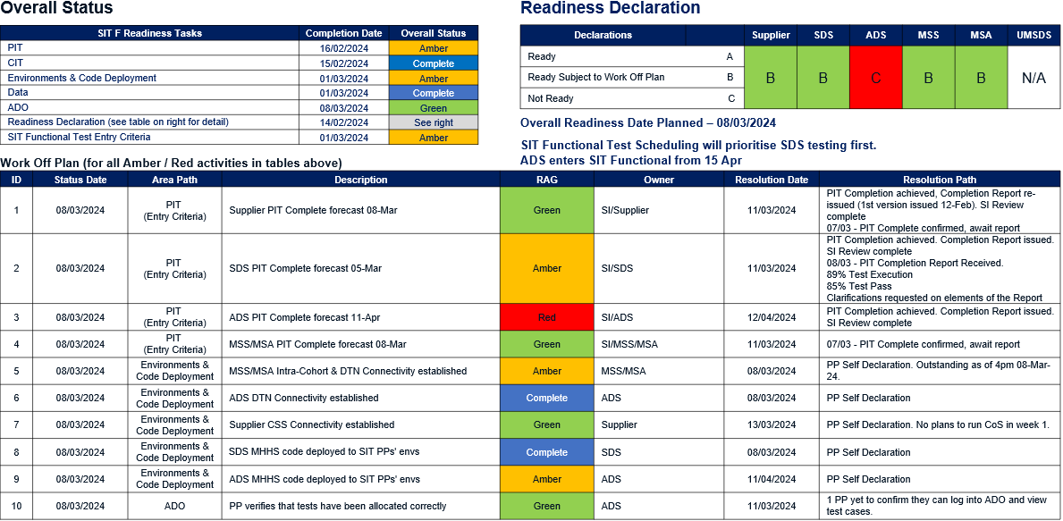
Figure 3: SIT Functional Readiness Status – Cohort B

SIT Functional Readiness Status – Cohort C
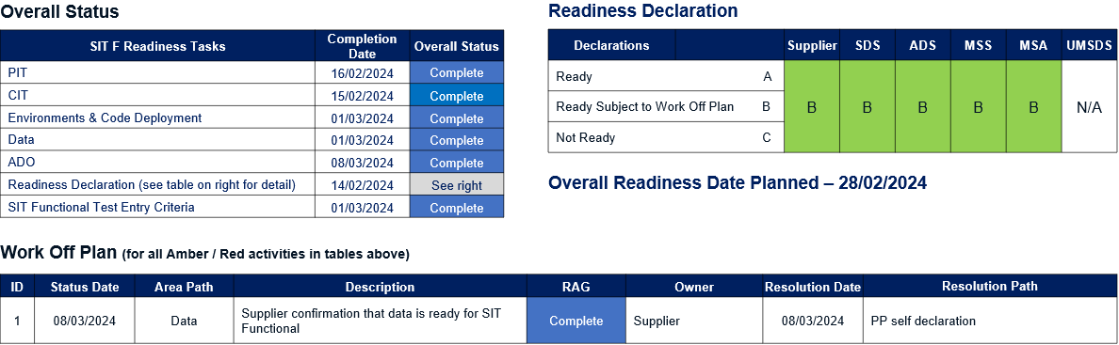
Figure 4: SIT Functional Readiness Status – Cohort C

SIT Functional Readiness Status – Cohort E
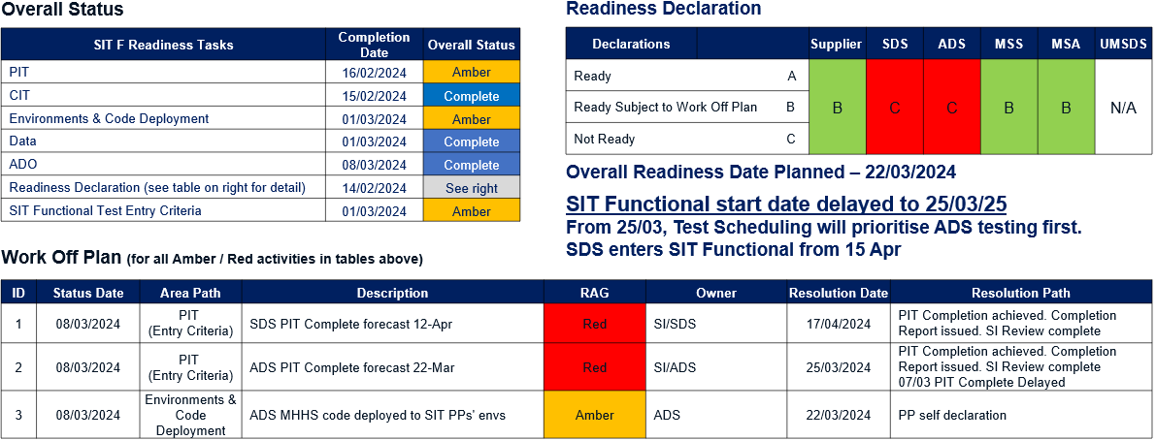
Figure 5: SIT Functional Readiness Status – Cohort E

SIT Functional Readiness Status – Cohort F
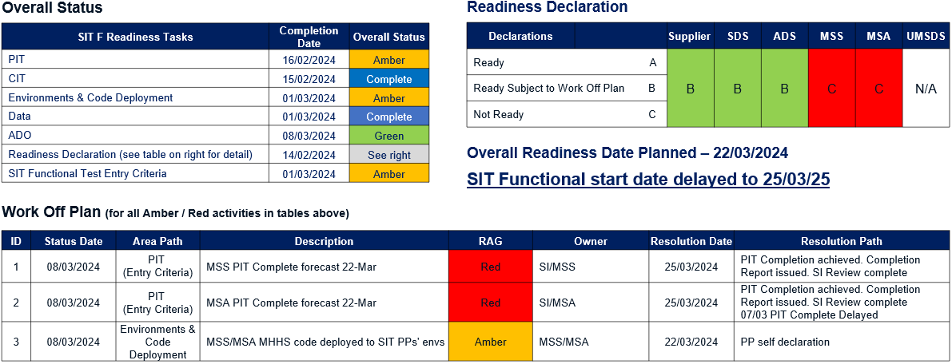
Figure 6: SIT Functional Readiness Status – Cohort F

SIT Functional Readiness Status – Cohort G
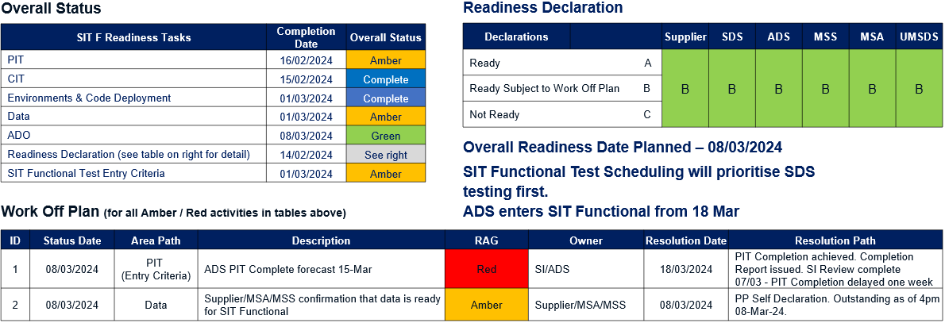
Figure 7: SIT Functional Readiness Status – Cohort G

SIT Functional Readiness Status – Cohort H
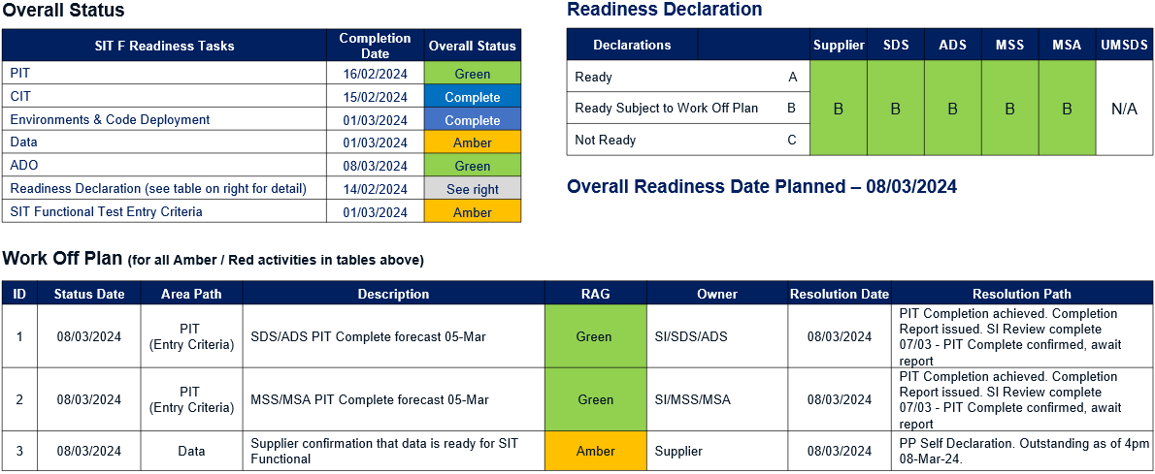
Figure 8: SIT Functional Readiness Status – Cohort H

SIT Functional Readiness Status – Cohort J
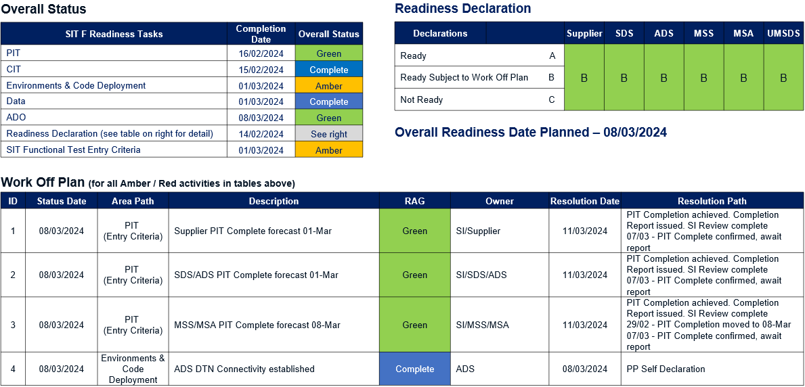
Figure 9: SIT Functional Readiness Status – Cohort J

Placing Reliance
The MHHS programme has reviewed the Placing Reliance proposal submissions provided by the concerned Qualifying MHHS participants prior to SIT CIT, in order to determine if there were any material impacts to those previous submissions in reference to the Cohort model which is being applied within SIT Functional. The assessment concluded that there were no material impacts to those prior submissions, however the programme did request that submissions for 3 Qualifying parties did require a minor wording change to reflect the data approach being dictated by the MHHS programme within the SIT Functional Test Cohort model for those parties. The revised submissions have been shared with the Code Bodies for comment.

Secondary Routing
During the early test intervals of CIT issues were found with Secondary Routing functionality. As a consequence, it was jointly agreed with the IPA and FTIG that the scope of CIT would be reduced to exclude the testing of Secondary Routing functionality. This had the effect of reducing the planned scope by approximately 66%. To mitigate the risk that the reduce scope introduced it has been agreed that additional Secondary Routing functionality testing be planned and executed. The following activities are in place and will cover:

SIT F Readiness Tasks | Completion Date | Overall Status
Avanade IR5.3 PIT | 22/02/2024 | Complete
Avanade IR5.3 PIT - SI Test Assurance/Test Witnessing | 15/02/2024 | Complete
Additional Secondary Routing Testing (Avanade PIT Environment) | 23/02/2024 | Complete
Deploy IR5.3 to SIT A Test Environment | 27/02/2024 | Complete
Secondary Routing Confidence Testing (SITA Test Environment) | 29/02/2024 | Complete
Table 1: Secondary Routing Activities
There is currently one work off item for Secondary Routing functionality:

Status Date | Area Path | Description | RAG | Owner | Resolution Date | Resolution Path
29/02/2024 | PIT | DIP Routing based on DCPIDs | Complete | SI/DIP | 06/03/2024 | Defect found during PIT Test Witnessing.  Defect has been fixed and Avanade retested and awaits SI Test Witnessing  29/02 - Still outstanding (low impact)  07/03 - Witnessing successfully complete
29/02/2024 | SITA Build | DIP Uplift to IR5.3 + IR5.4 in SITA including Data Model refresh planned completion 06-Mar | Complete | SI/DIP | 06/03/2024 | DIP declare build complete  07/03 - completed on schedule
29/02/2024 | Secondary Routing | SITA Secondary Routing Confidence Testing | Complete | SI/DIP | 07/03/2024 | Delayed to enable completion of IR5.4 uplift. Will now be conducted against IR5.4 Build  07/03 - testing executed, DIP correctly routed all messages. Final Data Base checks completed
Table 2: Secondary Routing Work Off Items

SI SIT Functional Entry Criteria Status
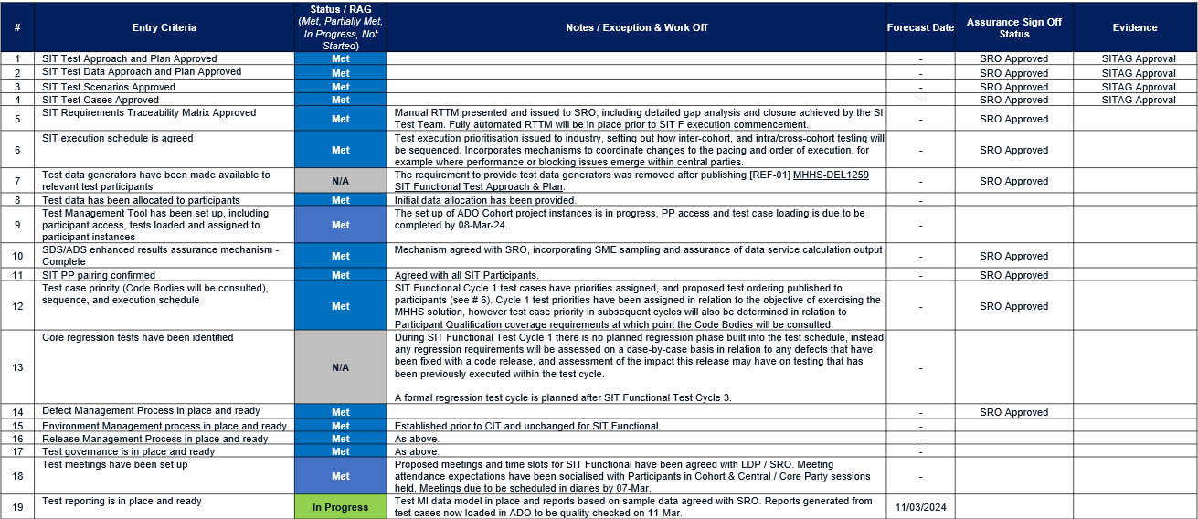
Table 3: SI SIT Functional Entry Criteria Status

SI Owned SIT Functional Readiness Work Off Items
SIT Stage | Owner (PP/SI) | Task Category | Cohort(s) | Party / Role | Task | Start Date | Finish Date | Status (RAG) | Commentary | Forecast Date
SIT F | SI | Reporting | All | All | SITF Test MI Set Up |  | 26/02/2024 | Green | Test MI data model in place and reports based on sample data agreed with SRO. Reports generated from test cases now loaded in ADO to be quality checked on 11-Mar. | 11/03/2024
SIT F | SI | Meetings | All | All | Test and Defect Meetings Scheduled with PPs |  | 07/03/2024 | Complete
SIT F | SI | DITL | All | All | Day In The Life Sessions |  | 07/03/2024 | Complete
SIT F | SI | CIT | All | SI | SI Overarching CIT Completion Report Approved by SITAG |  | 08/03/2024 | Green | eSITAG on 11-Mar | 11/03/2024
SIT F | SI / PP | ADO | All | All | Test Management Tool Training Complete |  | 08/03/2024 | Complete
SIT F | SI | ADO | All | All | Tests loaded in ADO |  | 08/03/2024 | Complete
Table 4: SI owned SIT Functional Readiness Work Off Items

SIT Functional Preparation – Milestones, Statuses & Work-off Plans

SIT Functional Preparation – Milestones, Statuses & Work-off Plans (Part I)
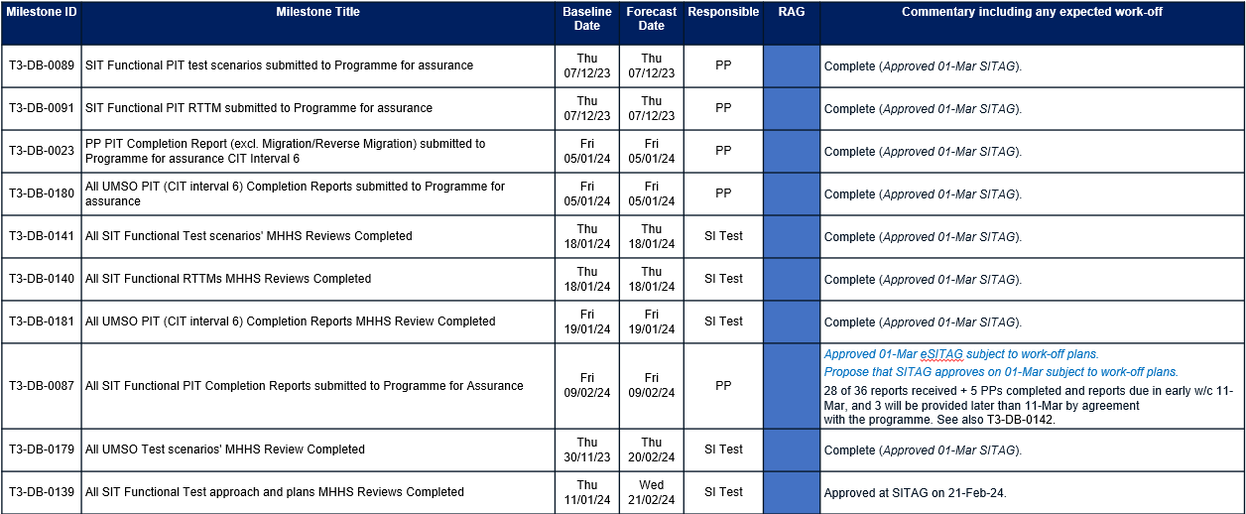
Table 5: SIT Functional Milestones Pt I (as of 08-Mar-24 at 4pm)

SIT Functional Preparation – Milestones, Statuses & Work-off Plans (Part II)
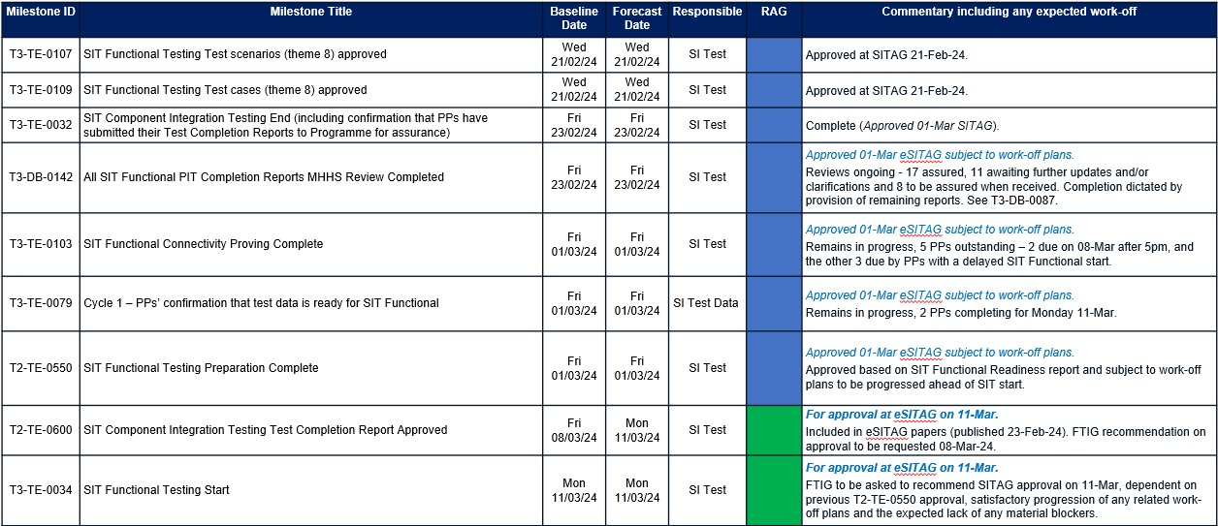
Table 6: SIT Functional Milestones Pt II (as of 08-Mar-24 at 4pm)

Risks & Issues
There are no newly identified Risks or Issues at this stage. Please see [REF-07] (RAID Log)

SI SIT Functional Readiness Recommendation
Based on the content of this this report at the time of writing the MHHS SI recommendation is to proceed with SIT Functional execution start, subject to the completion of all outstanding Work Off Plan items in the SIT Functional Status reports in Section 2 above.

Appendix A – SIT Functional Readiness Tracker
See embedded spreadsheet, SIT Functional Readiness Tracker that contains the lower-level evidence to support the figures shown in Sections 2 and 5

